**FIT5147 Visualisation Project**

**Melbourne housing property price analysis and prediction**

**Zhean Ma**

**Student ID: 29205883**

**1. Introduction**

Melbourne has been one of the most popular in the world in recent years, which brings the increase of price of housing. This report aims to explore some analysis based on data from public website by using pandas and R to do wrangling, and provide an interactive and visualization method by using shiny R, to find which part affects price the most. Finally , using a linear regression to make a prediction model to get the predicted price based on analysed variable.

From result from last assignment I get , the variable of distance to CBD and region are the most related factors to Melbourne housing price. So in this assignment, I choose to analyse and compare by using ggplot, Sankey, chord chart to see how location and distance affects price and finally set up a linear regression to do a prediction by using related variables.

The intended audience are people who want to buy housing property and property sales company in Melbourne.The CEO and analysts of property sales company will more care about which area and how long distance to open a building project to sell. analysts will get a predication of housing sale based on a linear regression. For buyers they may more focus on the balance of price and position.

Clarification of Changes of visualization project:

Former presentation for this assignment I choose D3 to do this project but after several days struggling, there are so many bugs in d3 and I can not run it successfully because of 404 or other bugs which I can not solve, so I choose to change use R shiny to do this project and change some sheet content.E.g: the map graph always can not run so I delete it.

**2. Design**

From result from last assignment I get , the variable of distance to CBD and region are the most related factors to Melbourne housing price. So in this assignment, I choose to analyse and compare by using ggplot, Sankey, chord chart to see how location and distance affects price and finally set up a linear regression to do a prediction by using related variables.

In visualisations part,. Ggplot shows the relationship of price and distance to CBD, which in geom_point() and geom_area(). Chord chart shows which part affects choice of property more greatly in price&distance aspects. Sankey chart shows Property selecting when in aspects of considering price and distance. A linear regression to predict price by inputting distance to CBD.

So The five design sheets are created:

In sheet2 is ggplot chart shows in geom_point view and geom_area view, how housing price changes with distance to CBD changing in different area. The advantage of ggplot chart is that it can clearly shows the relationship of 2 variables in different region. The different region names in sheet2 can be shown a matched graph in main panel by clicking representing radio button. In point view, it can easily show price changes with distance changing. It shows when distance is near CBD, the price tends to be higher while when distance is far, price will be lower. For focus, The blue tooltip shows specific information of distance and price when mouse hovering on graph. Hence ggplot chart is a good visualization method to show relationship in different region.

in sheet3 there are 2 type chatrts: chord and Sankey. Chord chart shows which part affects choice of property more greatly in distance aspect. Chord chart shows which part affects choice of property more greatly in price&distance aspects. The advantage is that it is obviously that if one part is the biggest part, which means people buy house tends to buy distance to CBD in this part and can give a reference to input value of prediction in sheet 4. And it also classified into different colours so that it is easy to know details. Sankey chart shows Property selecting when in aspects of considering price and distance. Sankey shows Property selecting when in aspects of considering price in sheet 3. When selecting radio button price, it shows the specific process and choice how people choosing property in different price category. The advantage is to know the most people choice and trend in trading so that provide a reference to buy a most balanced housing property. For focus，the white tooltip shows specific information of how many choice in dataset when mouse hovering on graph. Hence chord and Sankey charts are good visualization methods to show details of people buying property.

In sheet4 is a linear regression to predict price by inputting distance. This page obviously shows a linear regression in sheet 4.it is obviously that this modelling is correct because upper 4 graphs demonstrate that this linear regression operates in good condition in residuals ,normal Q-Q and leverage. And the get a specific regression based on operation above. For a key operation: When input a value of distance than get a forecast price value in pink circle after click button “go”. The advantage is to get a predicted price quickly. for focus, it will show the linear regression based on analysed variables. Hence linear regression is a good visualization methods to get prediction price.

Sheet 5 is shown by the final overall page layout for the whole visualisation project. Users can enter into any pages by clicking tab button and navigator above. The side bar is on the top left side, users can change view option and region name by clicking the button so that can show related graph in ggplot page. The side bar is on the top left side so users can change variable factor by clicking the button so that can show related graph in Sankey and chord page. The side bar is on the bottom left side so users can get predicted value by clicking the button “go’ so that can get predicted price in linear regression page. Page 1 stand for ggplot, the advantage in view option, it can easily show price changes with distance changing. It shows when distance is near CBD, the price tends to be higher while when distance is far, price will be lower. and page 2 stands for snakey&chord , The advantage is that it is obviously that if one part is the biggest part, which means people buy house tends to buy distance to CBD in this part and can give a reference to input value of prediction in sheet 4. page3 stands for linear regression. The advantage is to get a predicted price quickly. for focus, it will show the linear regression based on analysed variables. Overall, the final layout design also has enough focus and operation to support shiny to operate, so it can fully demonstrate that this project can be beneficial for intended audience.

**3.Implementation**

Using R shiny to make interactive visualisation project:

Ggplot shows the relationship of price and distance to CBD, which in geom_point() and geom_area().

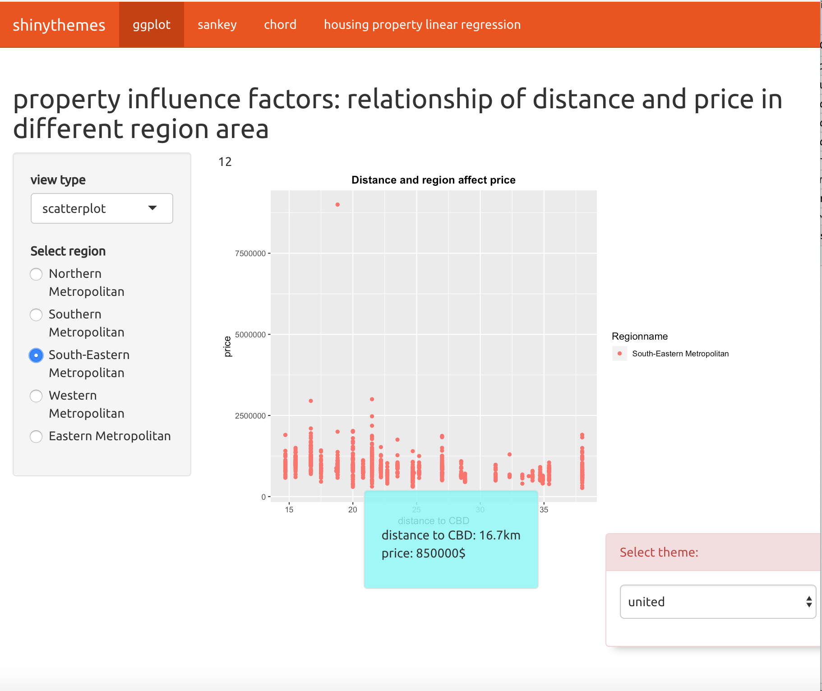

Chord chart shows which part affects choice of property more greatly in price&distance aspects.

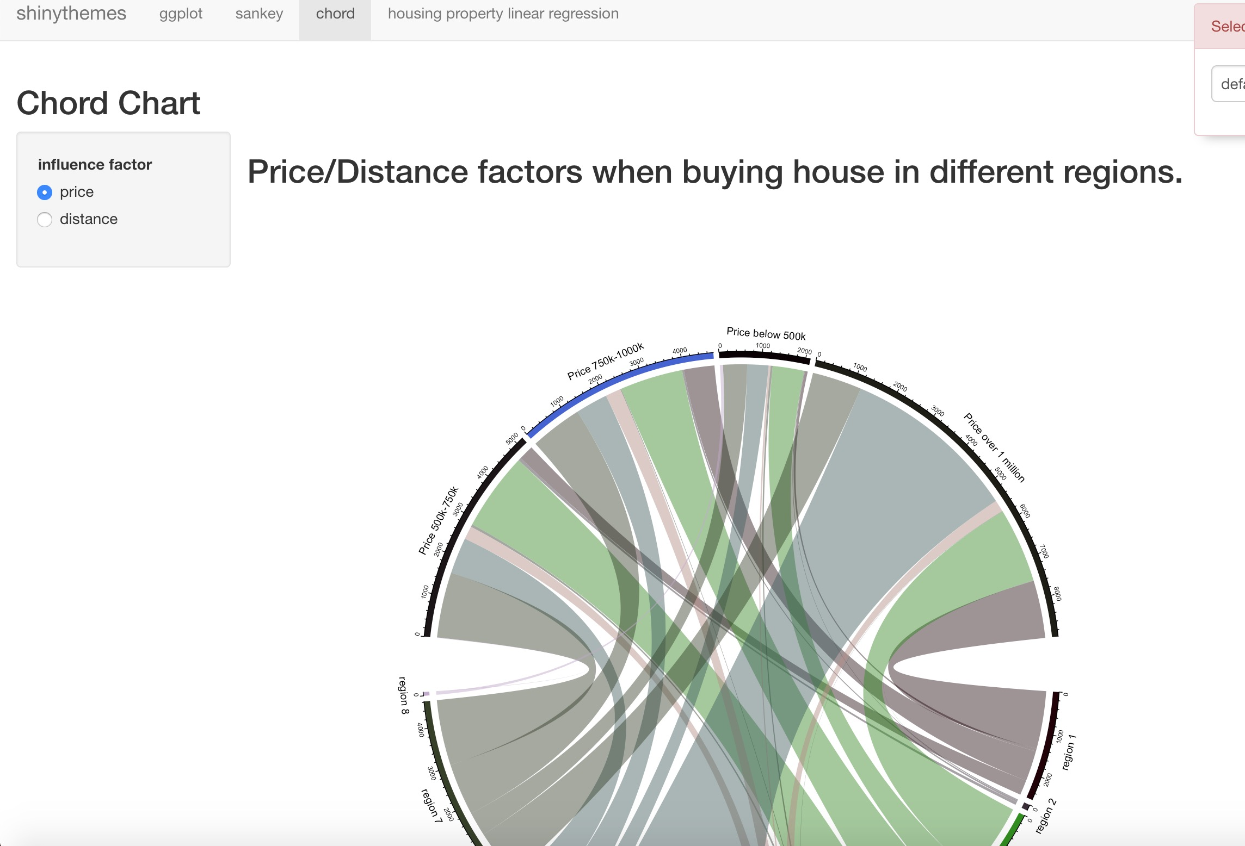

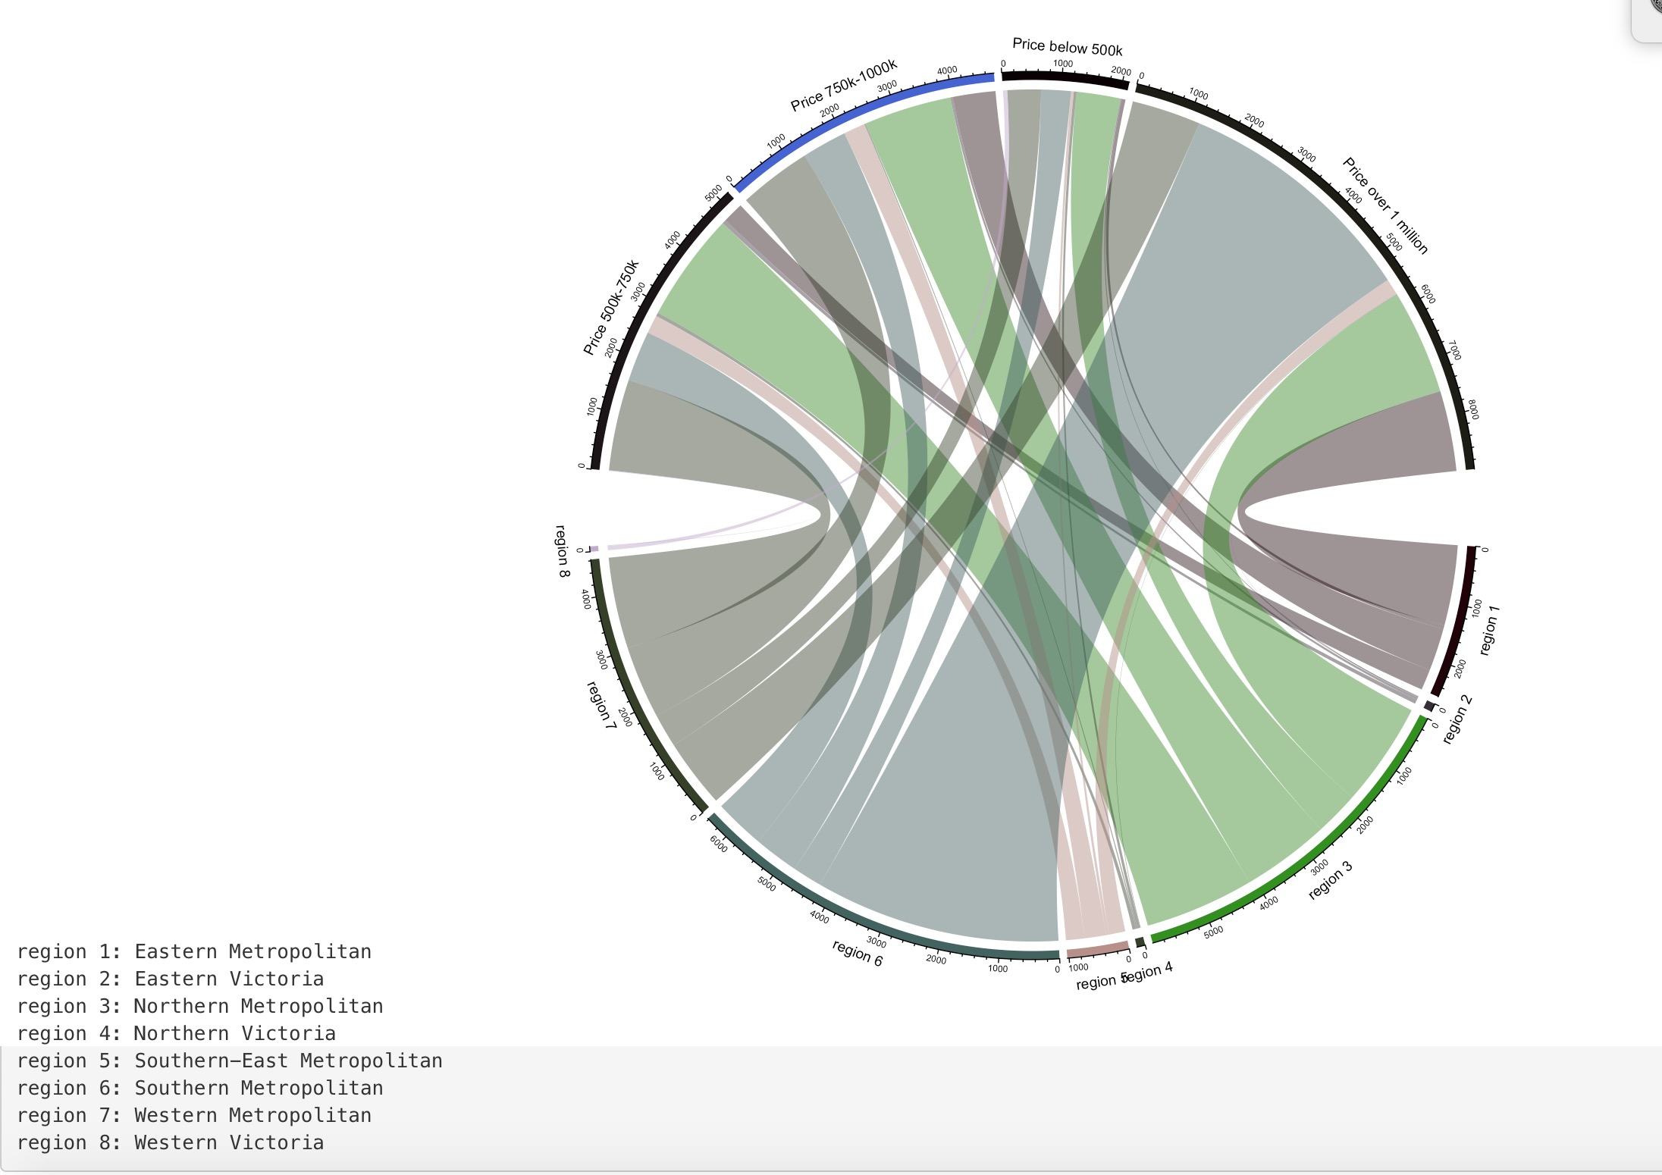

Sankey chart shows Property selecting when in aspects of considering price and distance.

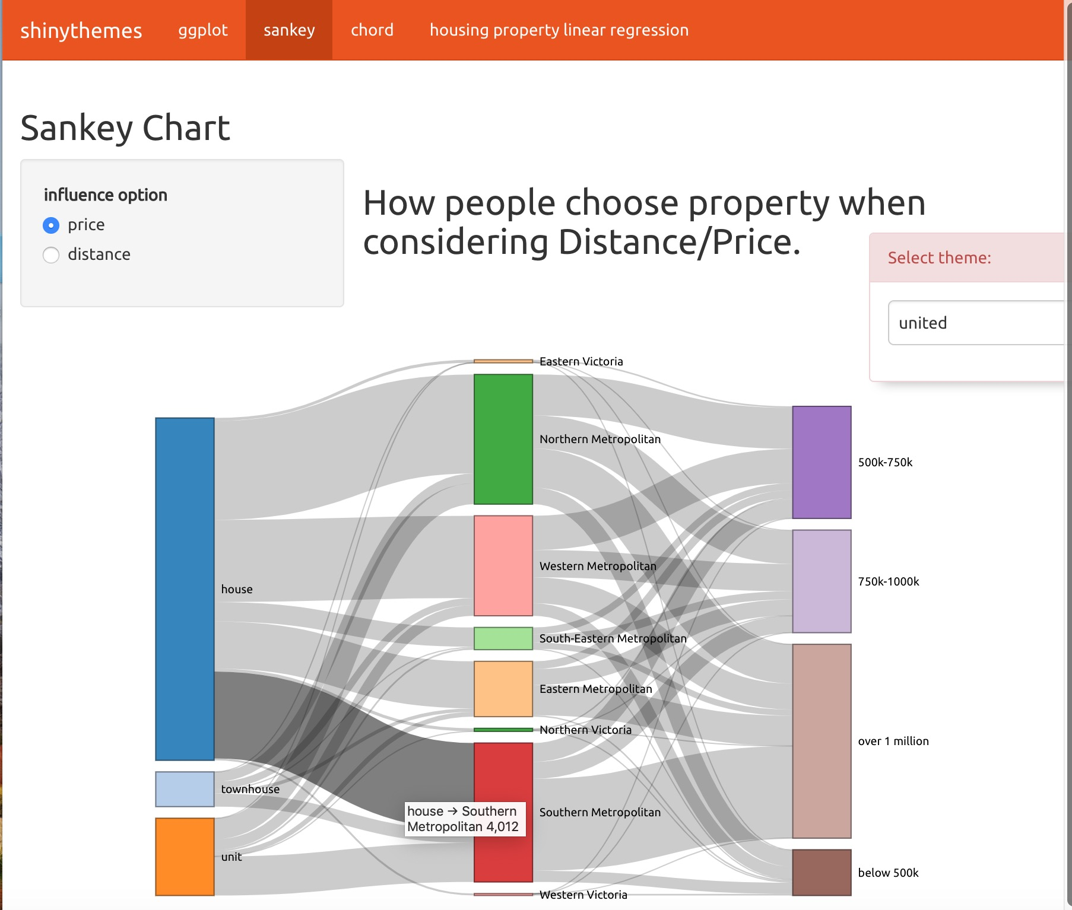

A linear regression to predict price by inputting distance

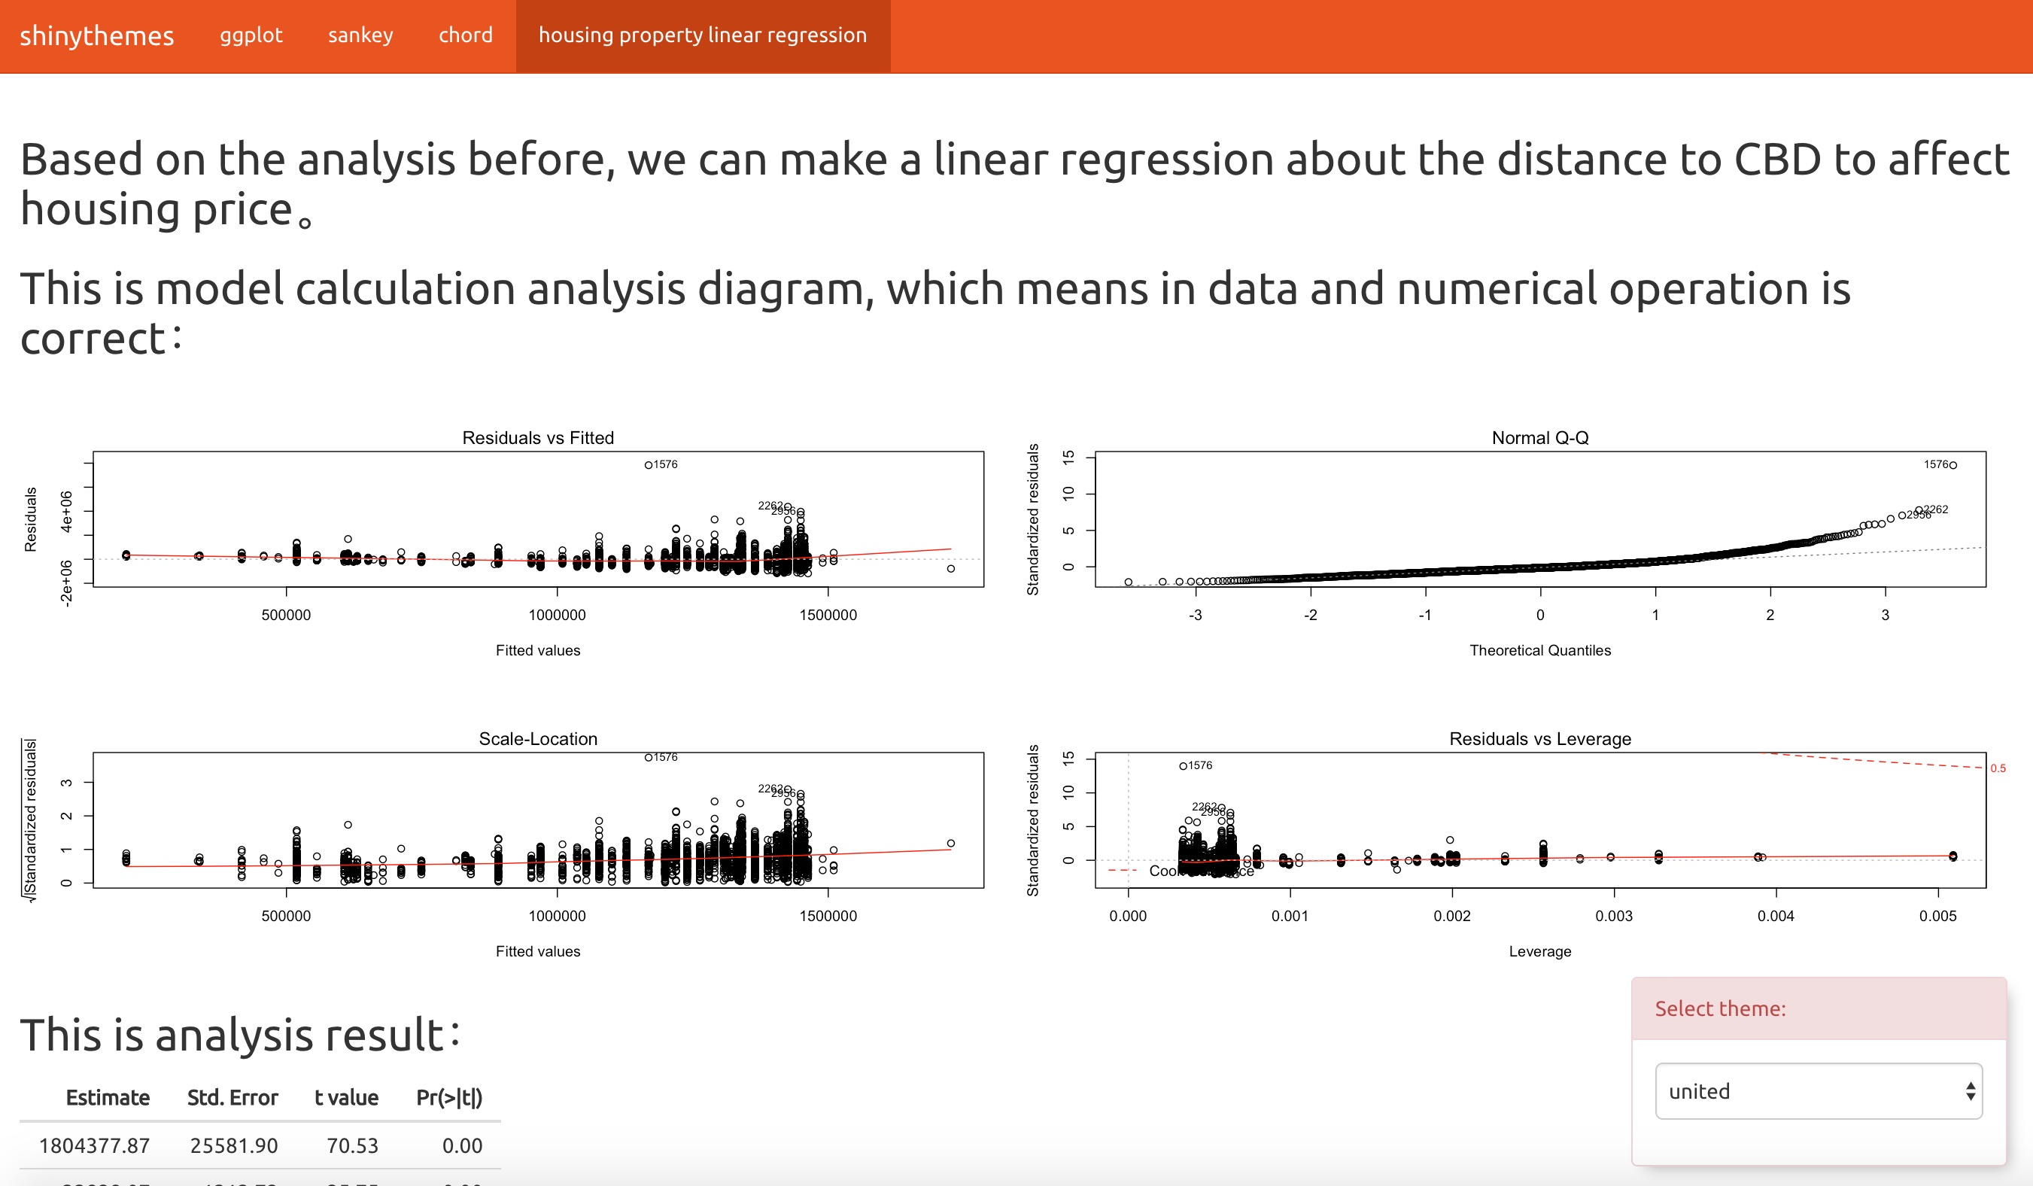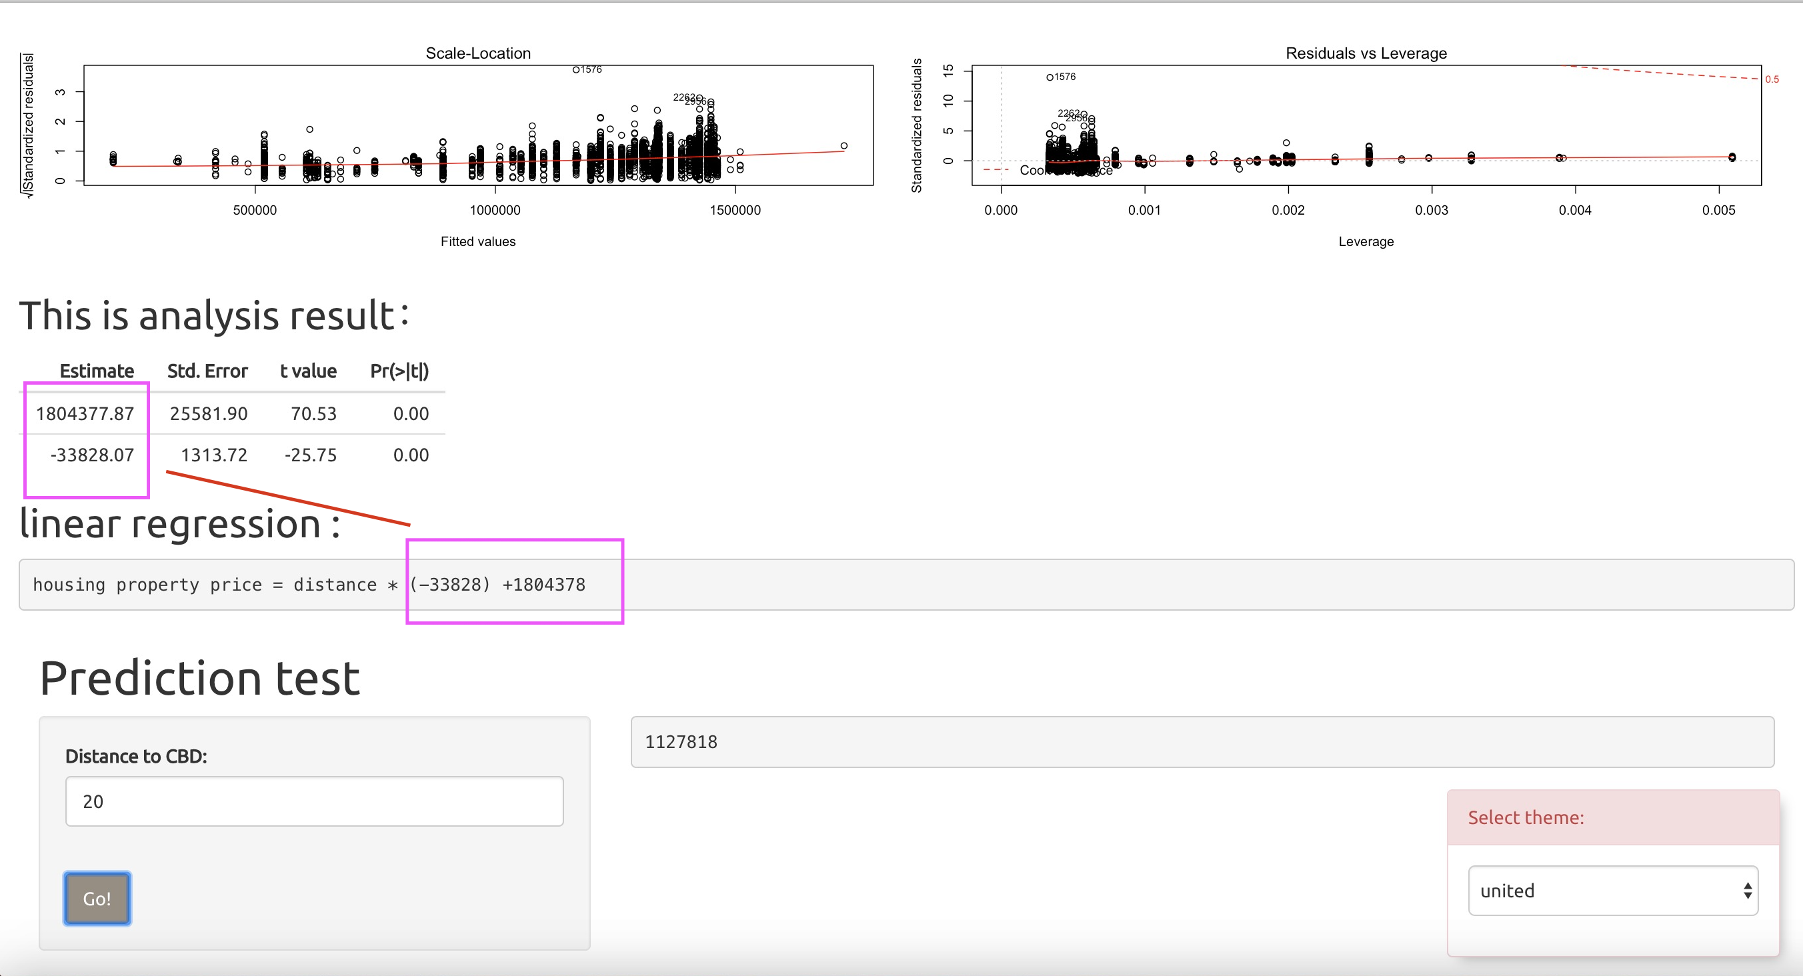

Those 6 screenshots shows sheet 5 situation of implementation. The ggplot shows in point view and area view, how housing price changes with distance to CBD changing in different area. The chord graph shows in different regions, what part of price/distance related with choice of housing property greatly. The Sankey graph ,shows how people choose housing property in distance and price aspects which can compare to show which aspect affects more obviously. Finally it is a modelling of linear regression, which shows the how changes of distance affects price and make a prediction of housing price by inputting distance.

Ggplot shows the relationship of price and distance to CBD, which in geom_area().

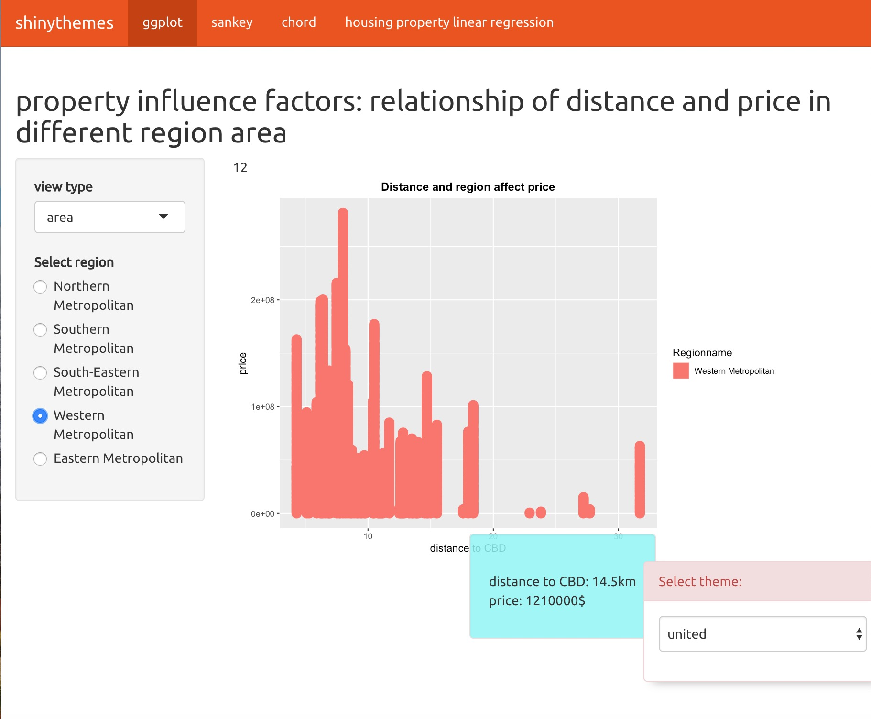

This screenshot obviously shows the relationship between distance and price in sheet 2. When selecting radio button western metropolitan, it shows when distance is near CBD, the price tends to be higher while when distance is far, price will be lower. The blue tooltip shows specific information of distance and price when mouse hovering on graph.

Sankey chart shows Property selecting when in aspects of considering price.

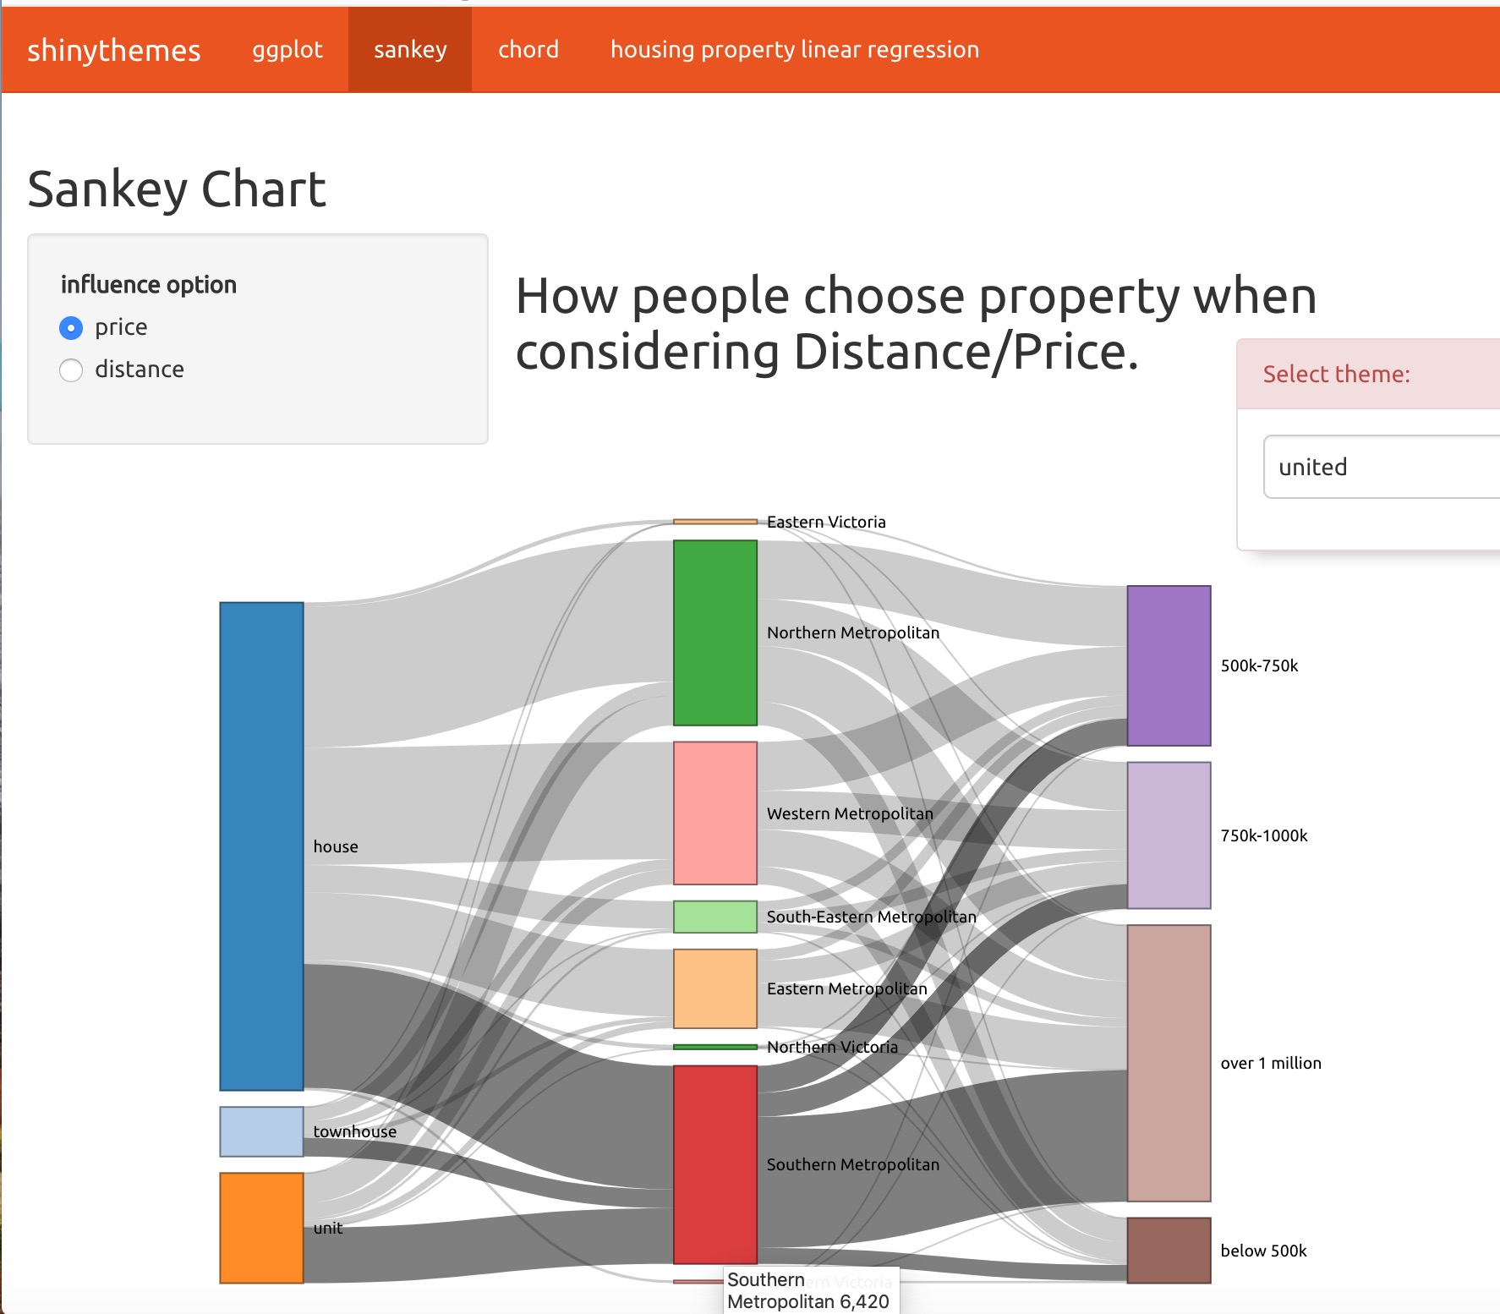

This screenshot obviously shows Property selecting when in aspects of considering price in sheet 3. When selecting radio button price, it shows the specific process and choice how people choosing property in different price category. The white tooltip shows specific information of how many choice in dataset when mouse hovering on graph.

Chord chart shows which part affects choice of property more greatly in distance aspect.

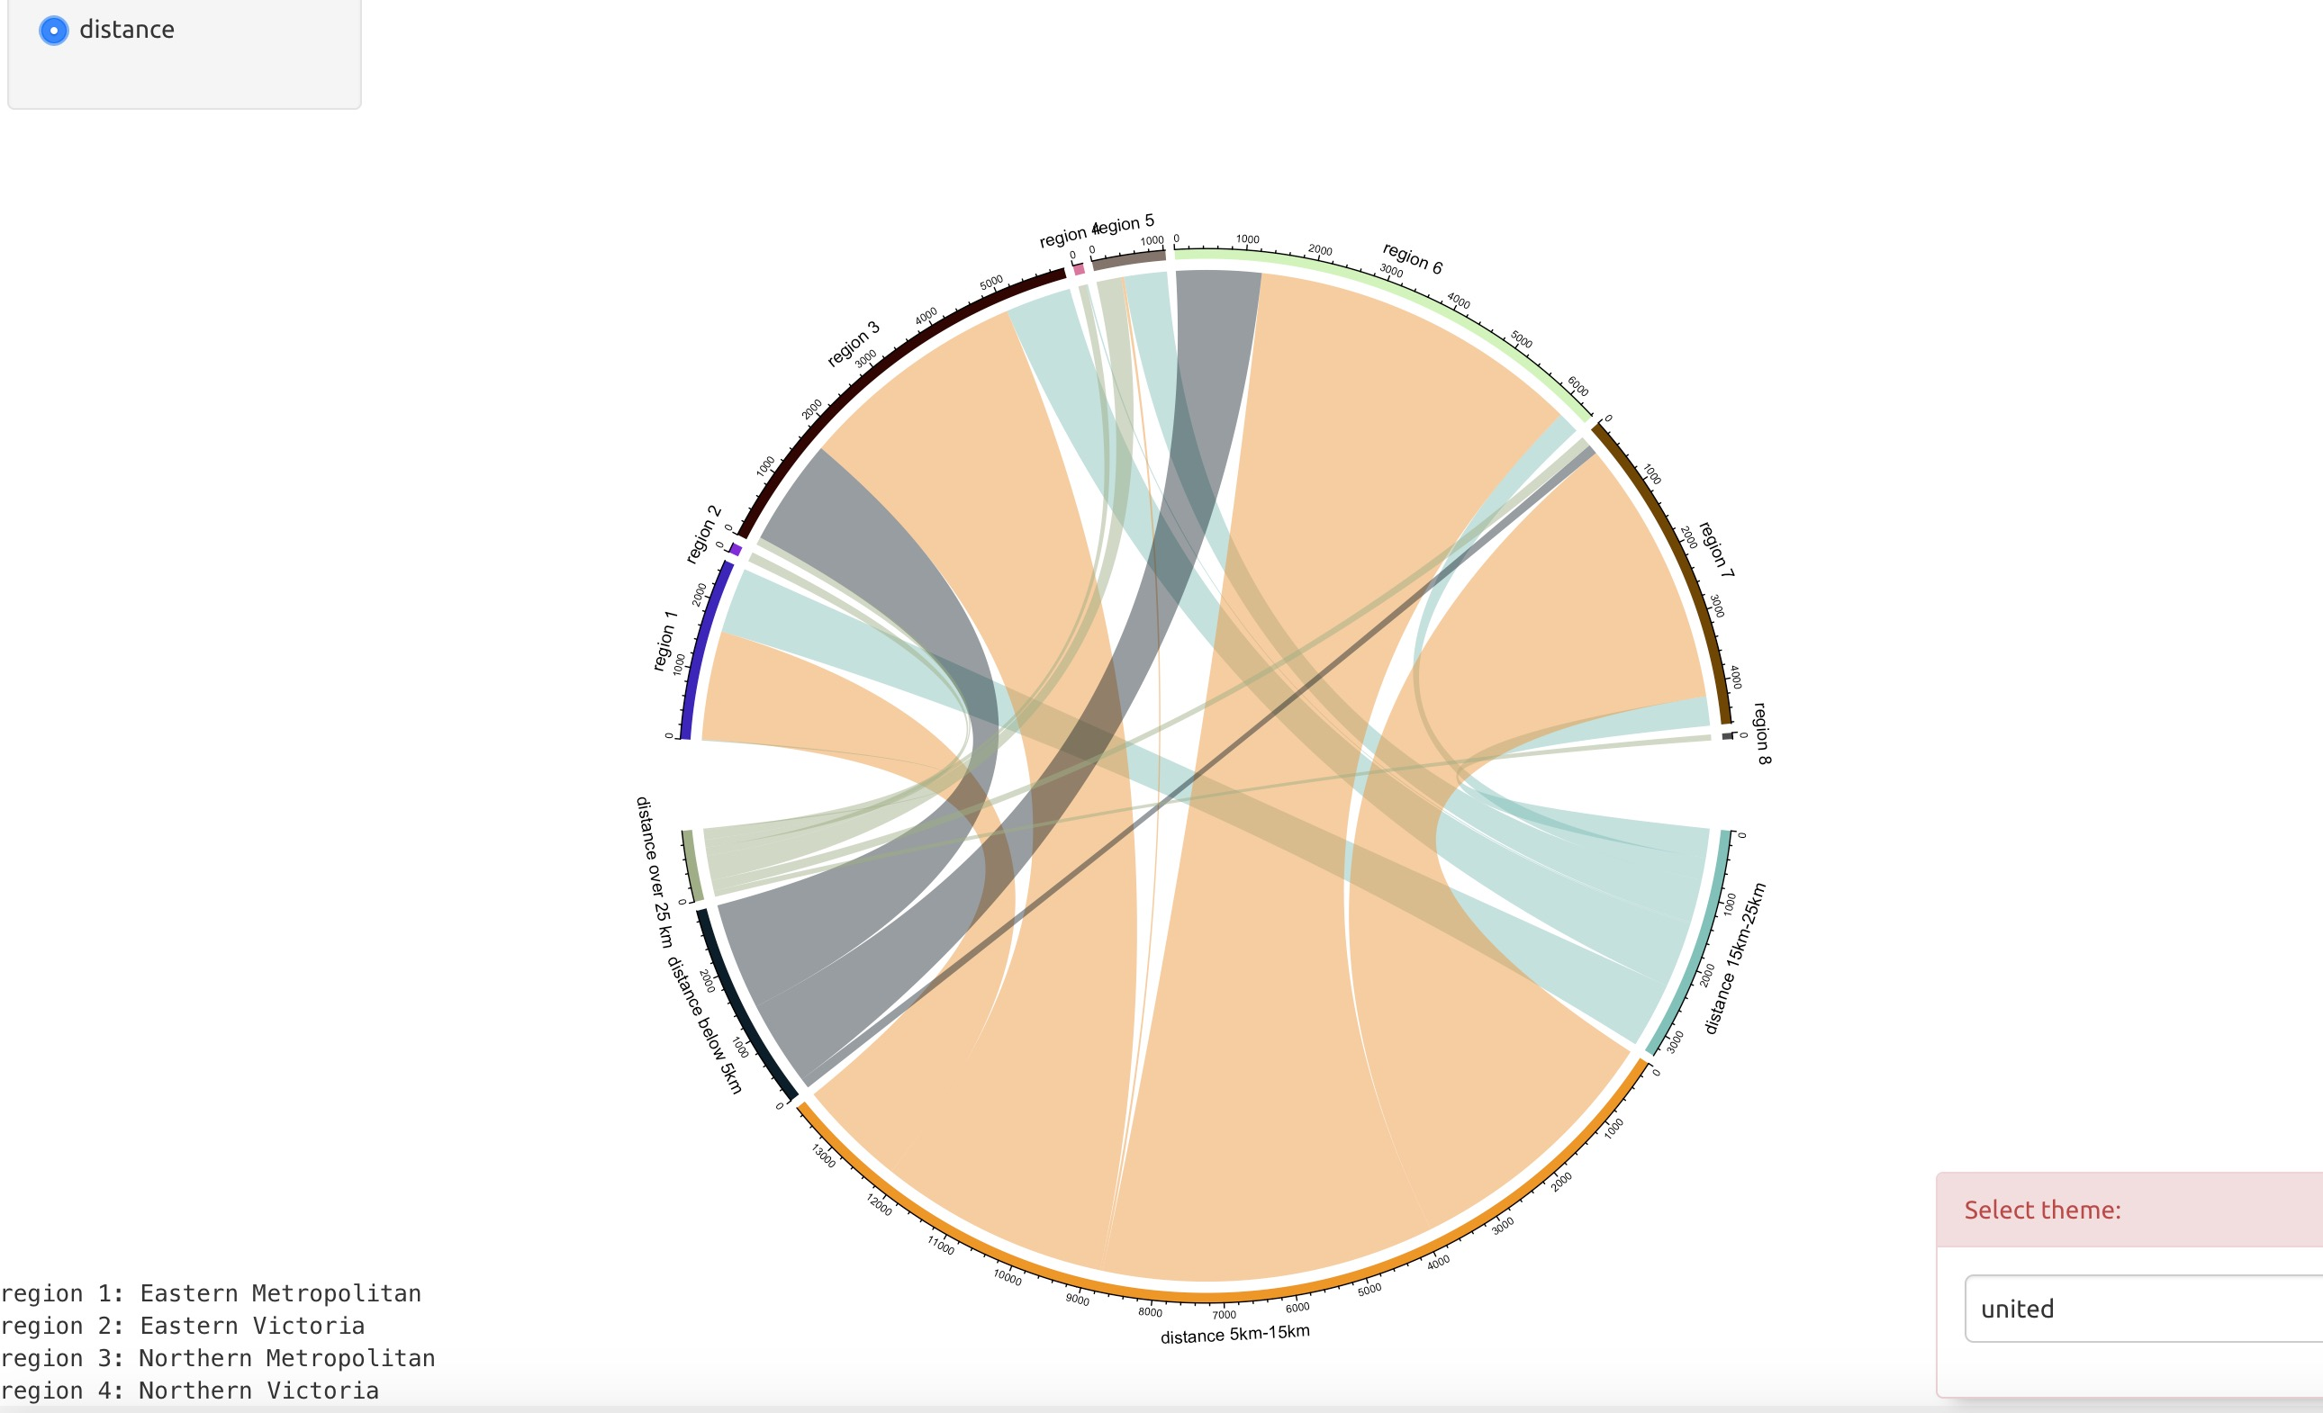

This screenshot obviously shows which part affects choice of property more greatly in distance aspect in sheet 3.it is obviously that orange part(5-15km) is the biggest part, which means people buy house tends to buy distance to CBD between 5-15km.

A linear regression to predict price by inputting distance





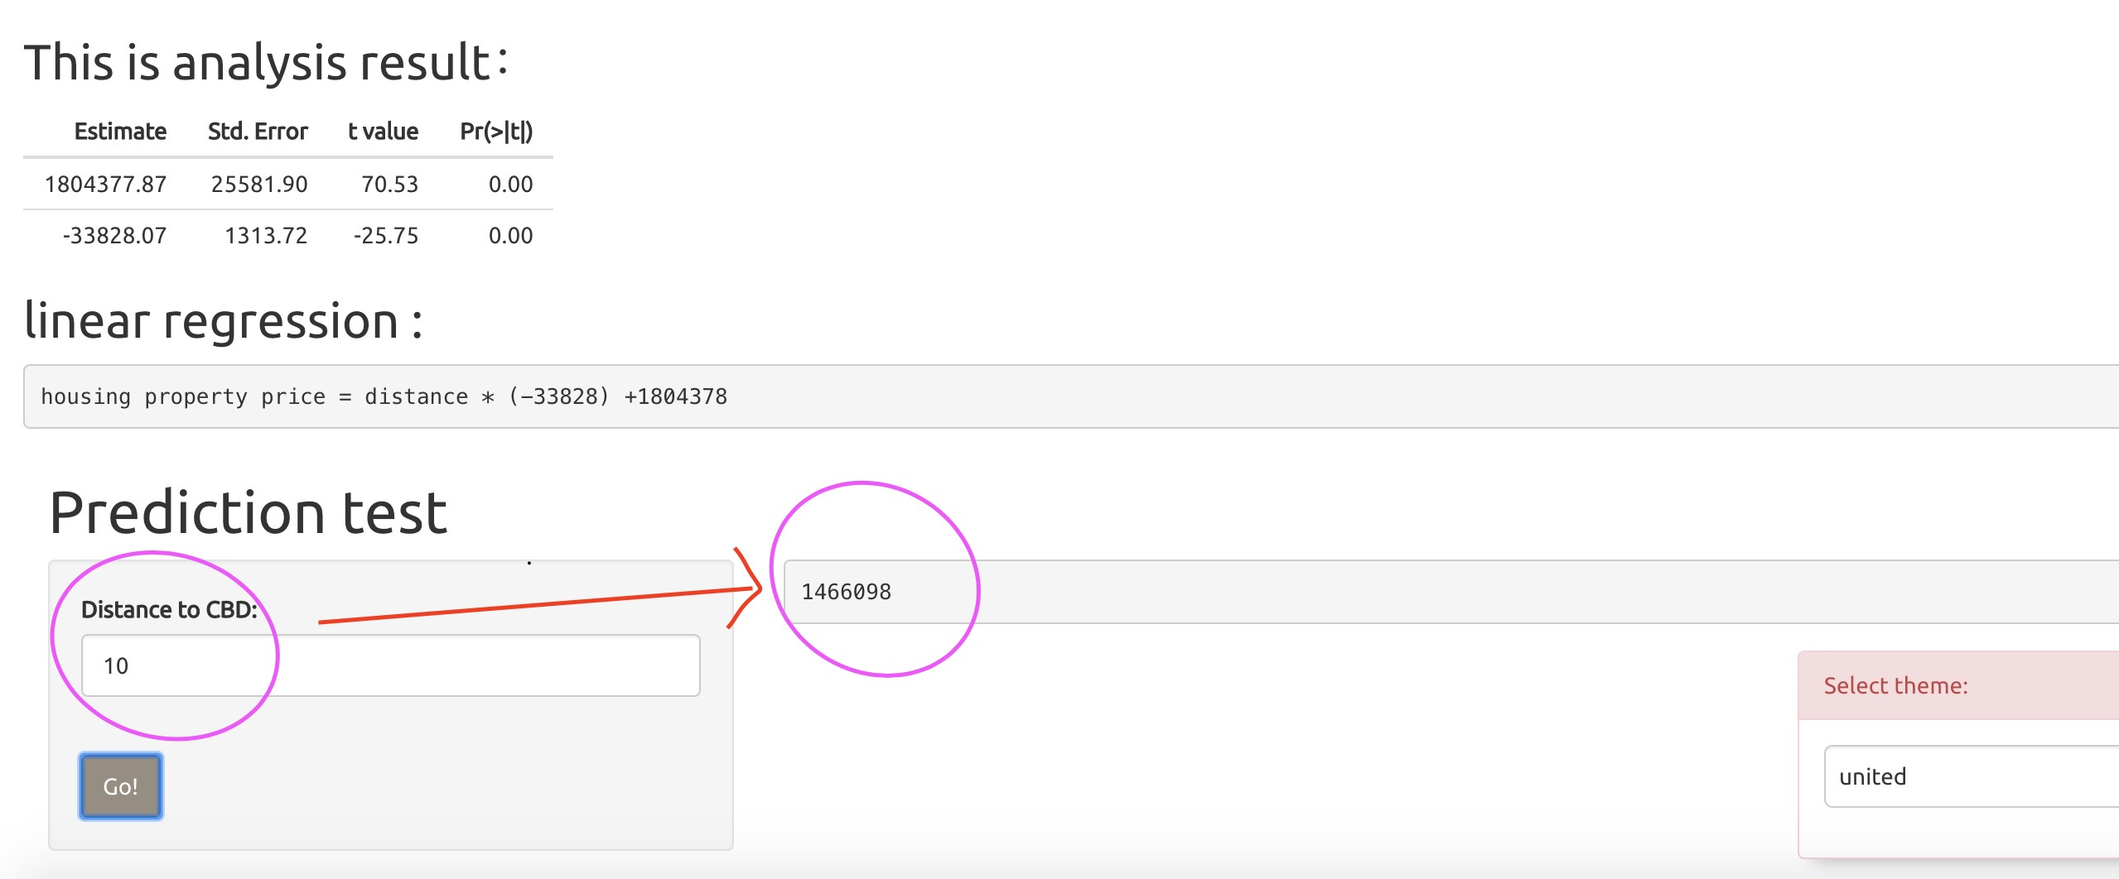

This screenshot obviously shows a linear regression in sheet 4.it is obviously that this modelling is correct because upper 4 graphs demonstrate that this linear regression operates in good condition in residuals ,normal Q-Q and leverage. And the get a specific regression based on operation above. When input a value of distance than get a forecast price value in pink circle after click button “go”.

Implementation of importing liberary:

library(shinythemes), library(shiny), library(ggplot2), library(rgdal) ,library(rgeos)

library(plyr), library(maptools), library(sp), library(plotly), library(networkD3)

library(chorddiag), library(circlize)

implementation of process:

1. Set up navigator and tab button to enter different web page of ggplot, Sankey, chord, housing price linear regression.
2. In page ggplot, set up a side bar containing view type -- geom_point() and geom_area() two view options. And then set up 5 region radio button which can yield graphs in main panel by clicking a radio buttion. And add the blue tooltip shows specific information of distance and price when mouse hovering on graph so that people can scan more conveniently.
3. In page Sankey/chord, set up radio button of a side bar containing factors of price and distance. And add the white tooltip shows specific information of how many choice in dataset when mouse hovering on graph.
4. In page housing property linear regression, set up a prediction test side bar and make a text input area. After inputting distance value, the main panel will show predicted price.

The advantages of these implementations to this visualisation:

a) Obviously show the relation between different variables in different radio button for this project. E.g. Chord chart shows which part affects choice of property more greatly in distance aspect.

b) Readers can easily reflect more specific information by hovering mouse on graph to get better understanding. E.g. The blue tooltip shows specific information of distance and price when mouse hovering on graph.

c) It is more interesting and interactive when adding linear regression to predict price by inputting the location which readers want. This shows this project more functions rather than just show comparation of data and variables.

**4. guide for user**

a) run shiny APP by clicking Run App button on the right top of the R studio page

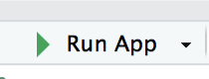

b) The navigator and tab button which can enter other pages by clicking is shown below:

c) in ggplot page:

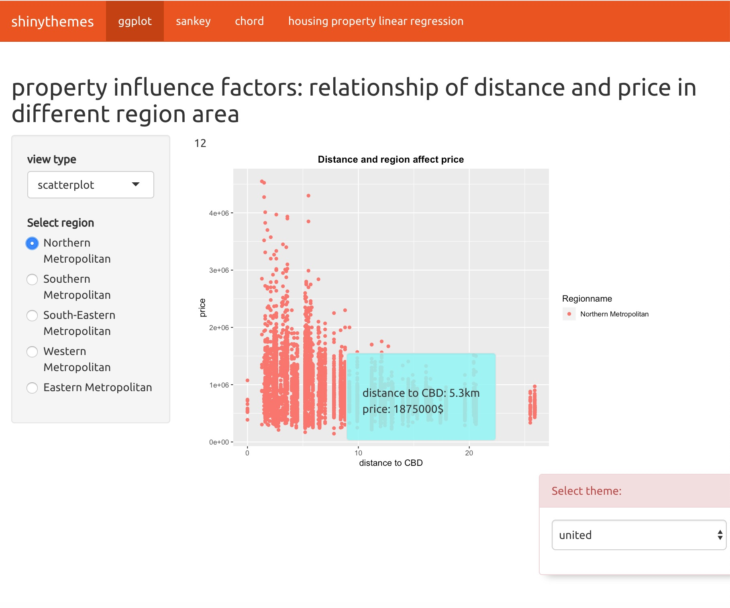

This graph shows the relationship between distance and price in different region.

From the left side bar, we can find the current view type is scatterplot, and current region is Northern metropolitan.

c) switch view option by clicking arrow under text View type.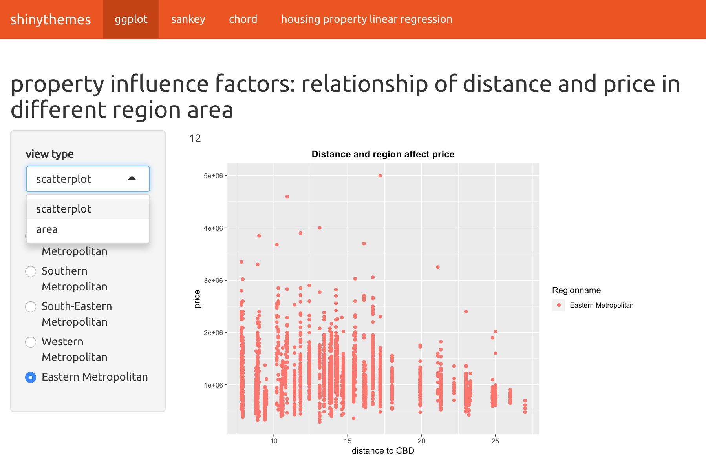

and can also switch graph by changing radio button of region name.



1. in chord and Sankey chart, we can switch graph by clicking radio button in side bar





1. in linear regression page ,we can input value and click button ‘go’ to get forecast value in panel. 

**5. Conclusion**

In the project it is very beneficial to design a narrative visualisation project and implementin shiny app . At first, choosing the intended audience is important for my vproject .After this process, I will select more detailed dataset and use more advanced visualization method to analyse the most related variable to prepare variables for sheet 4 linear regression. And generate new chord Sankey ggplot and linear regression to show some new visualisation charts by different view option. At last, when running this project in shiny App it will get a predicted price value by inputting location distance number. Intended readers will get upset when they need more detailed and advanced design and option. This problem will be corrected in further and provide a better visualisations.

**6. Reference**

“Melbourne housing market” by Melbourne House Pricing, Kaggle. https://www.kaggle.com/anthonypino/melbourne-housing-market

Shiny gallery, <http://shiny.rstudio.com/gallery/see-more.html>

Chord chart,

<https://www.r-graph-gallery.com/123-circular-plot-circlize-package-2/>

Appendix:

Sheet1:

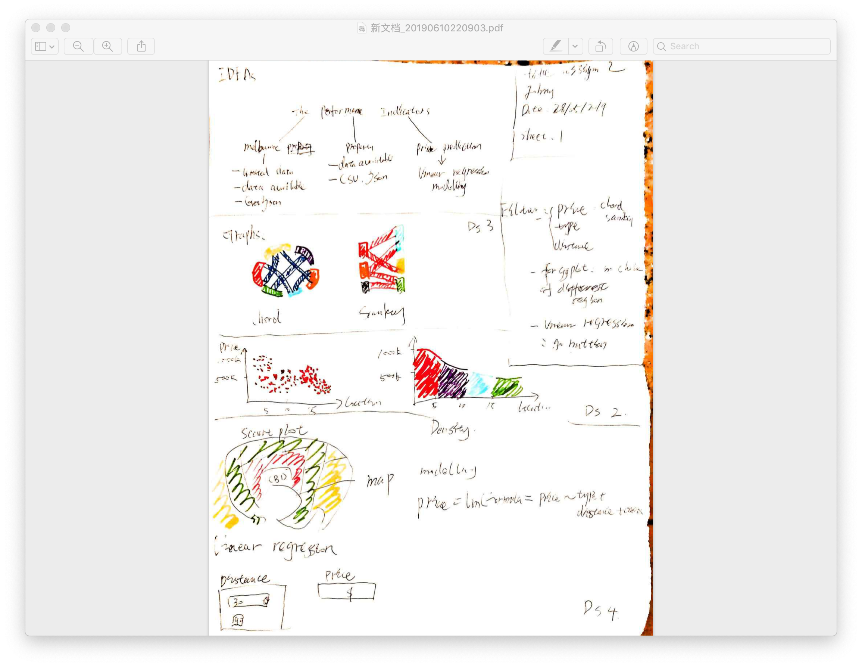

Sheet2:

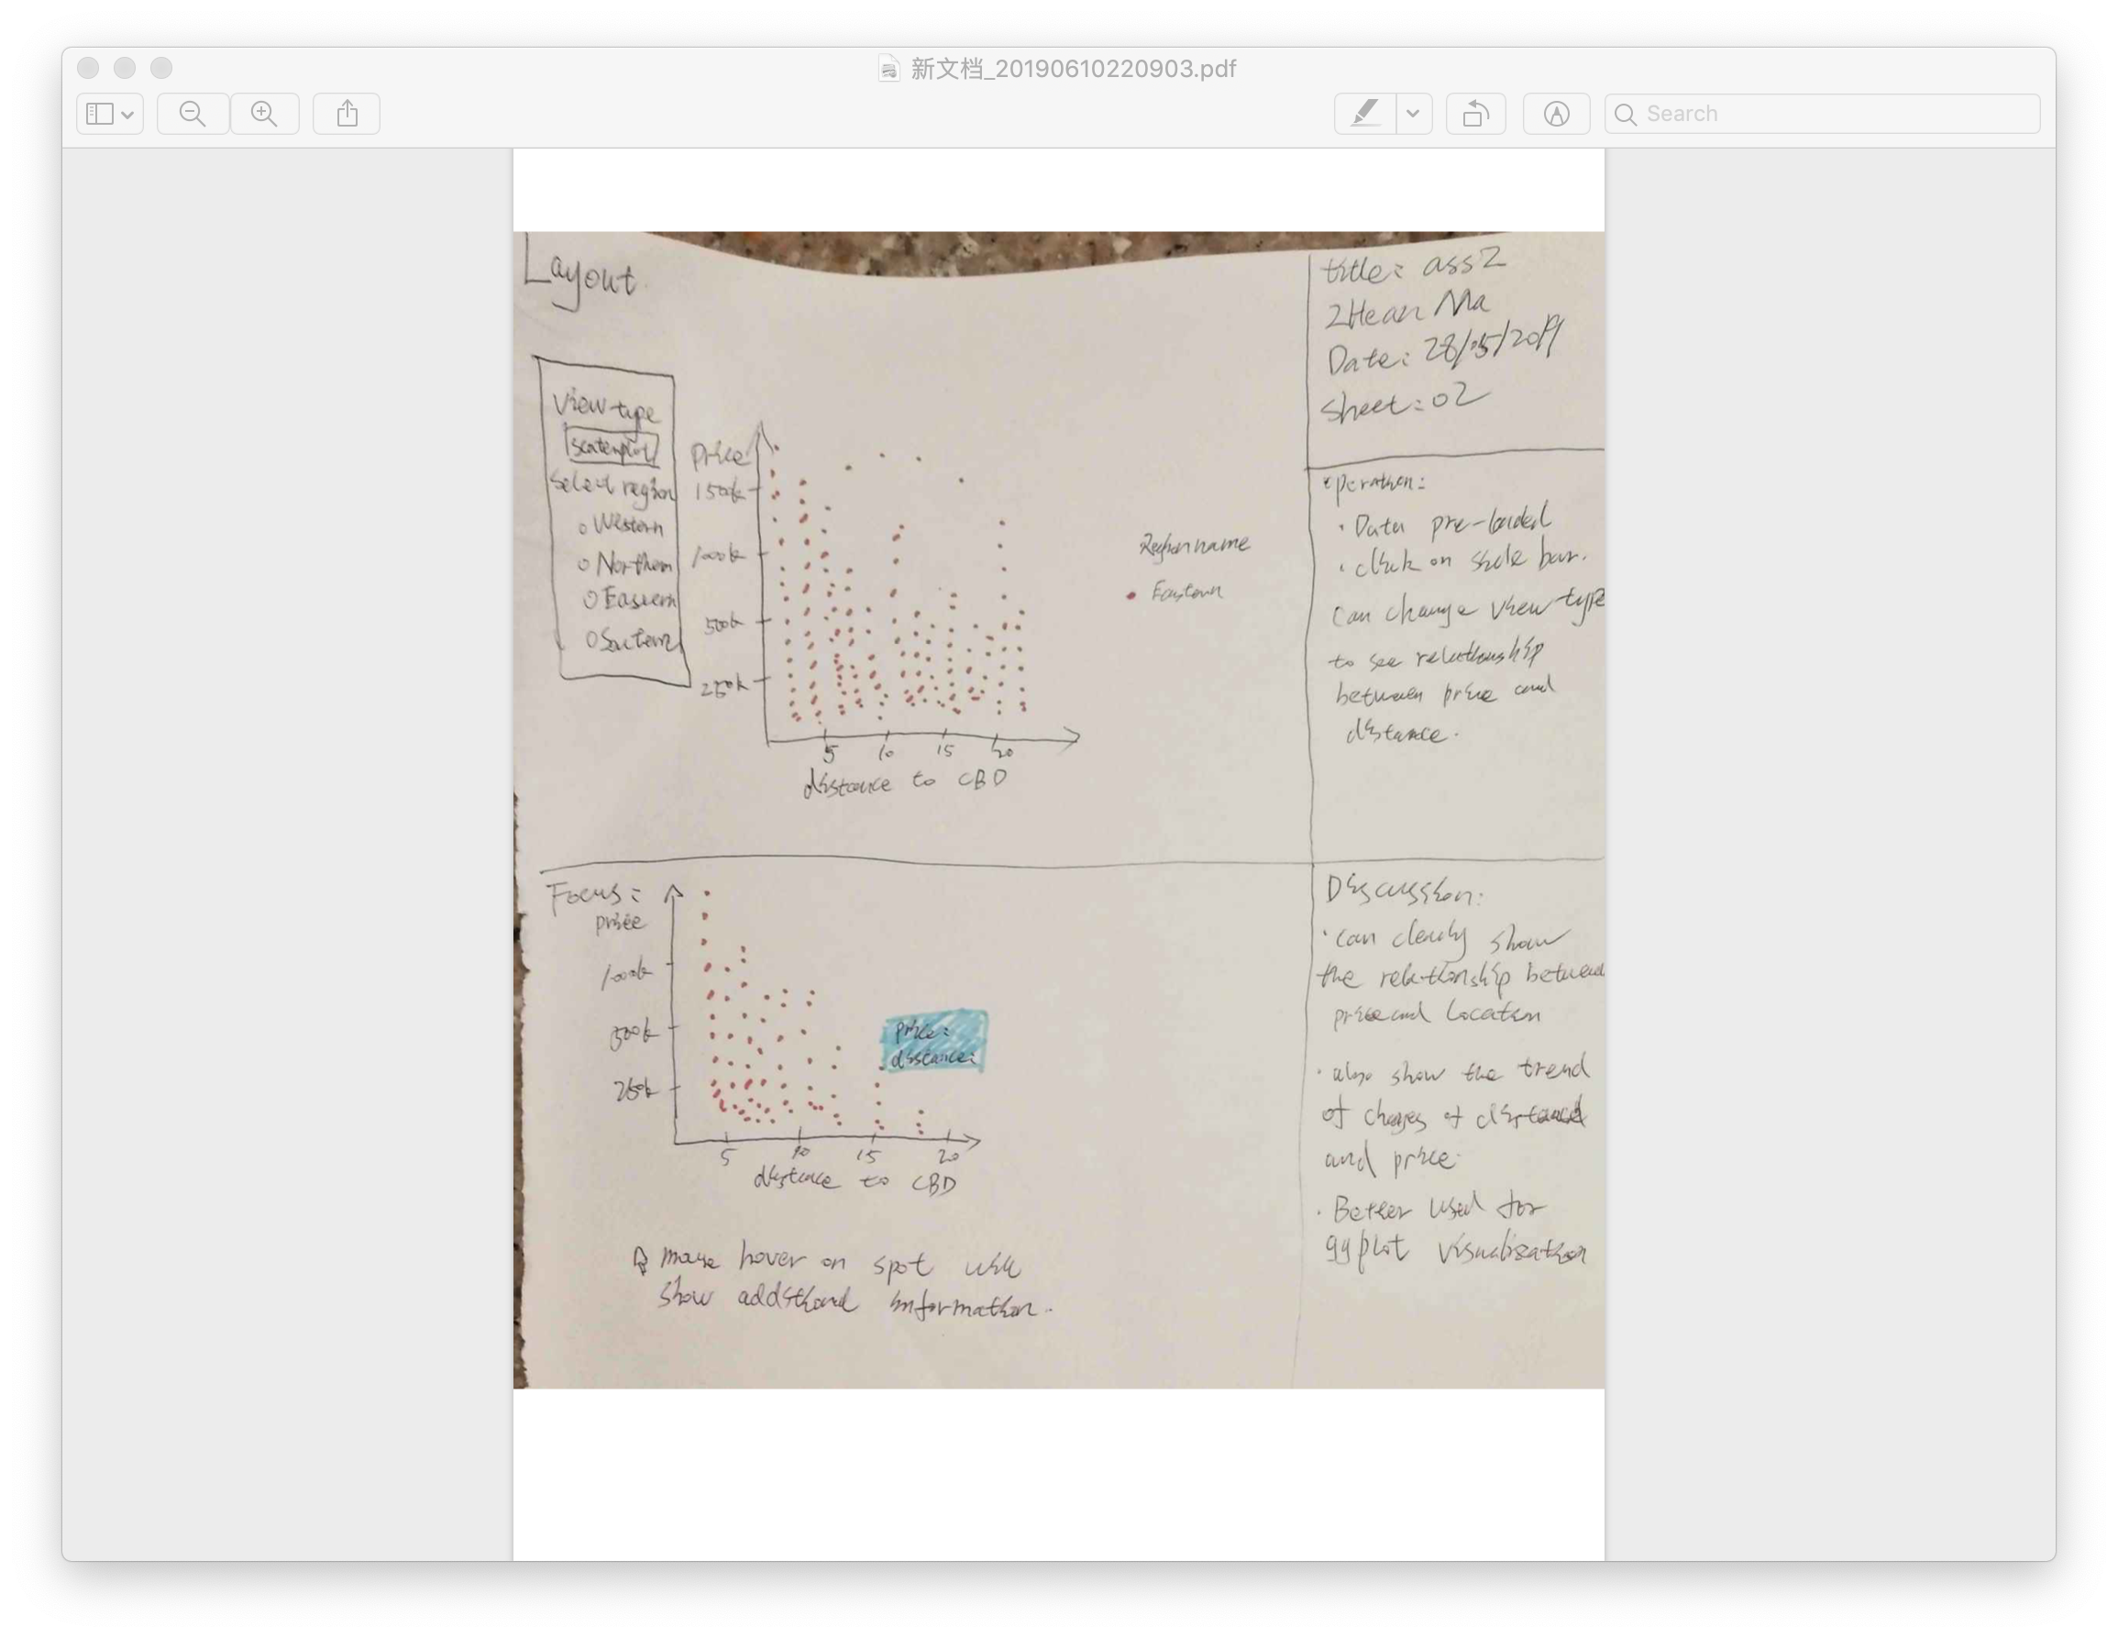

Sheet3:

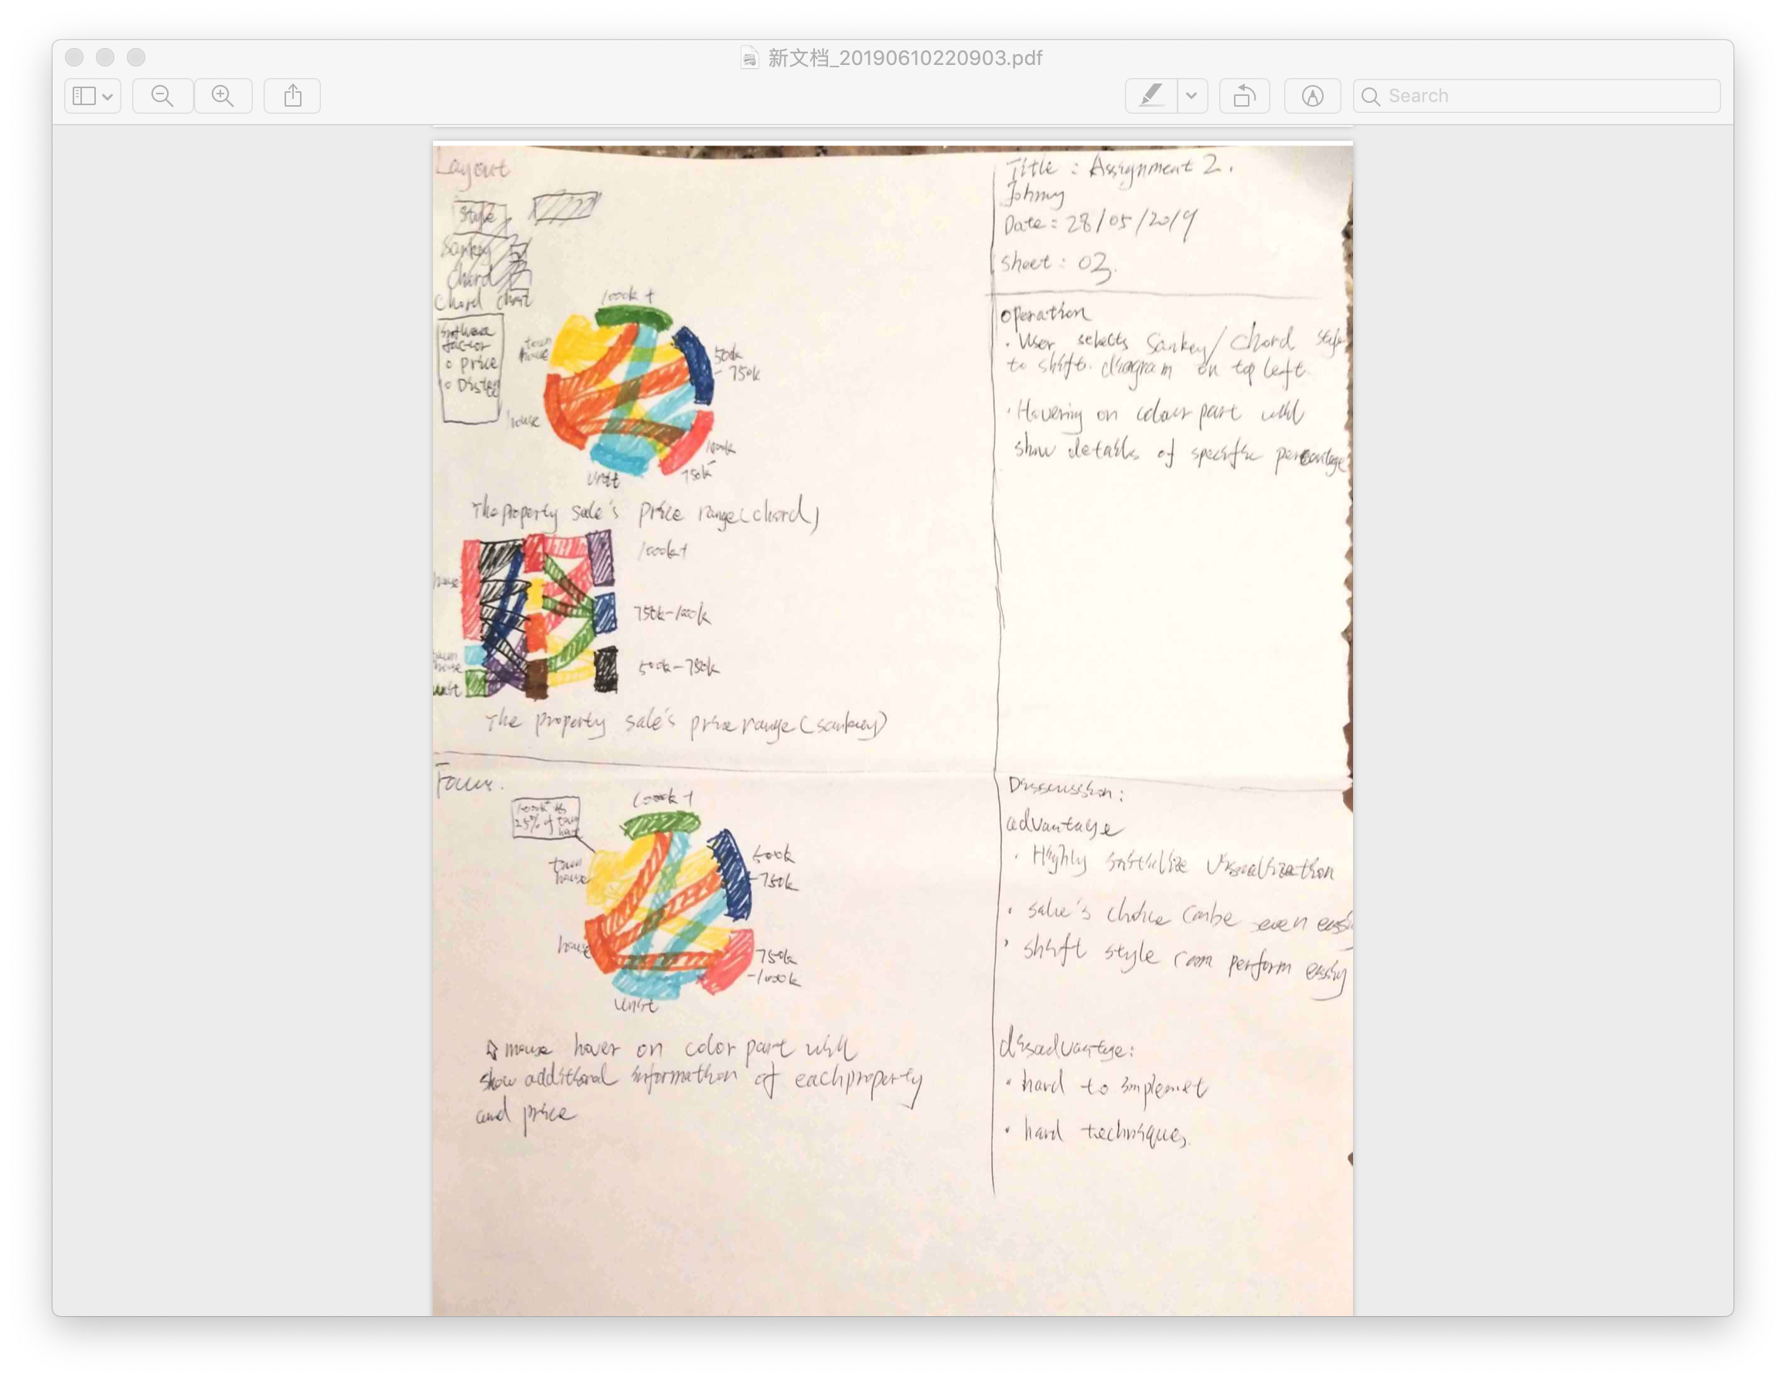

Sheet4:

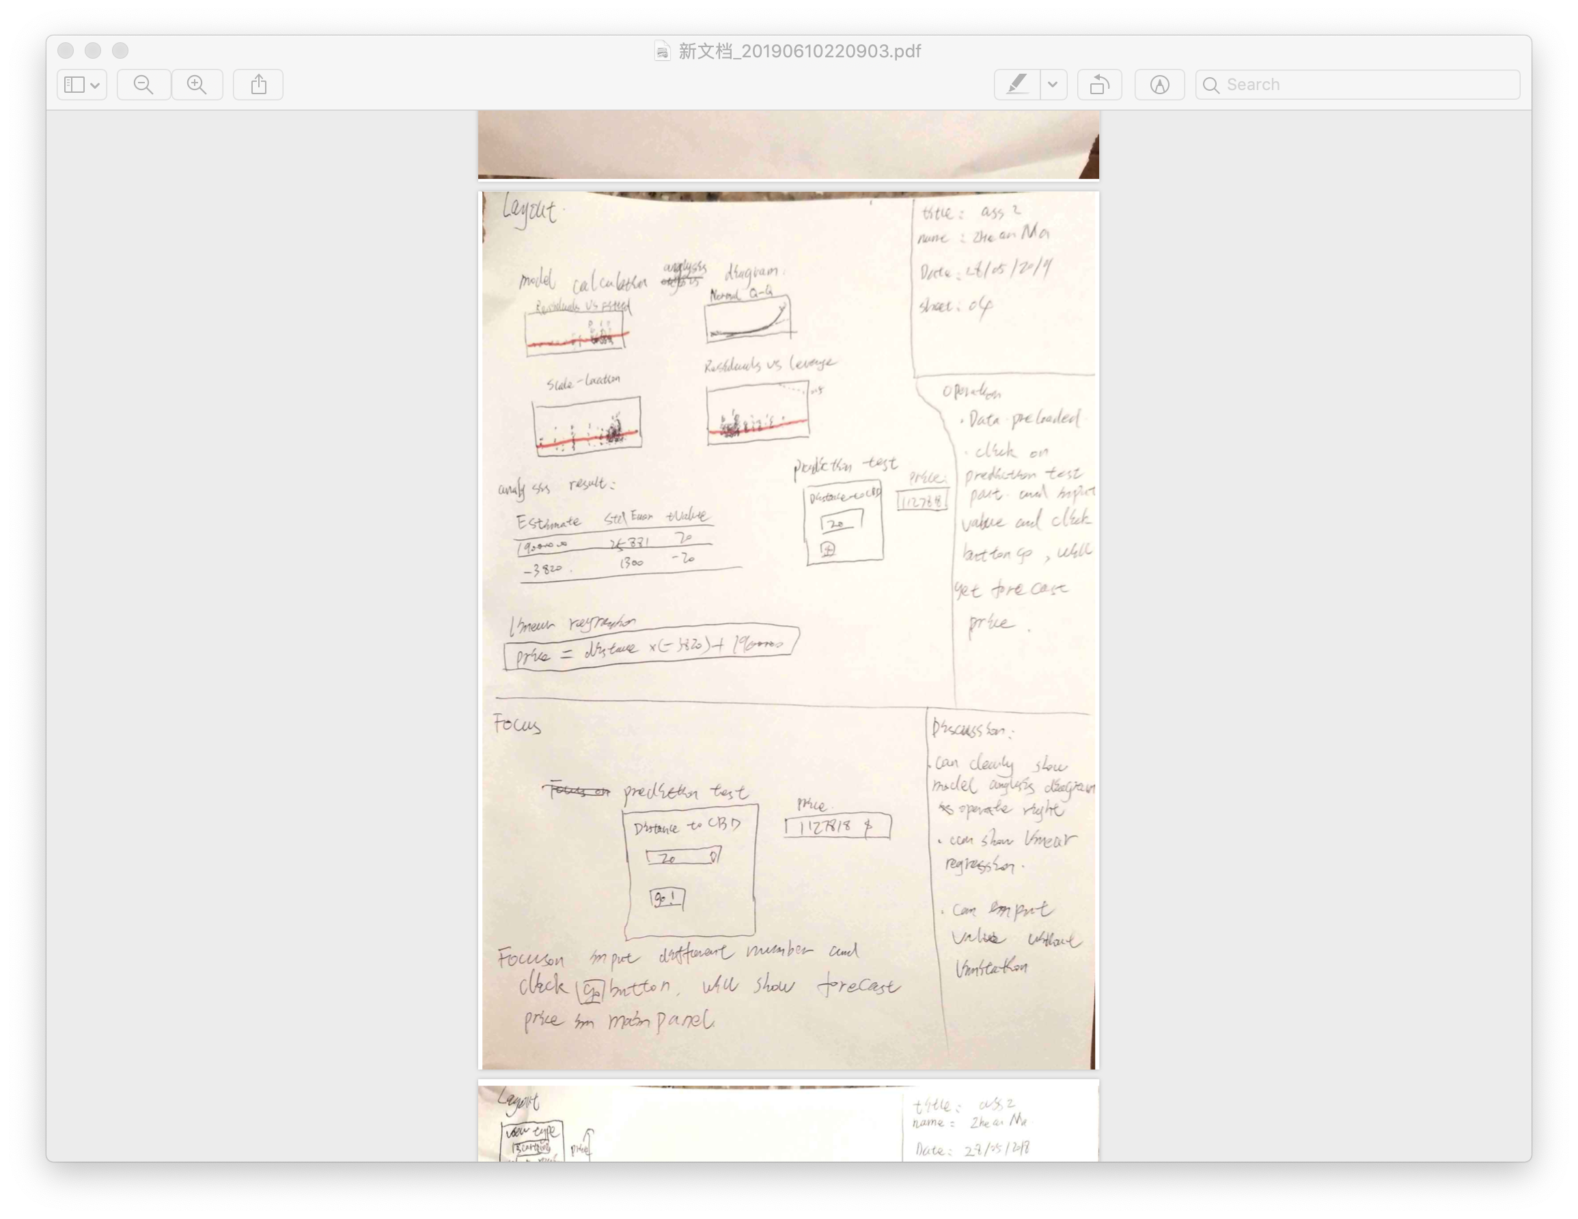

Sheet5:

